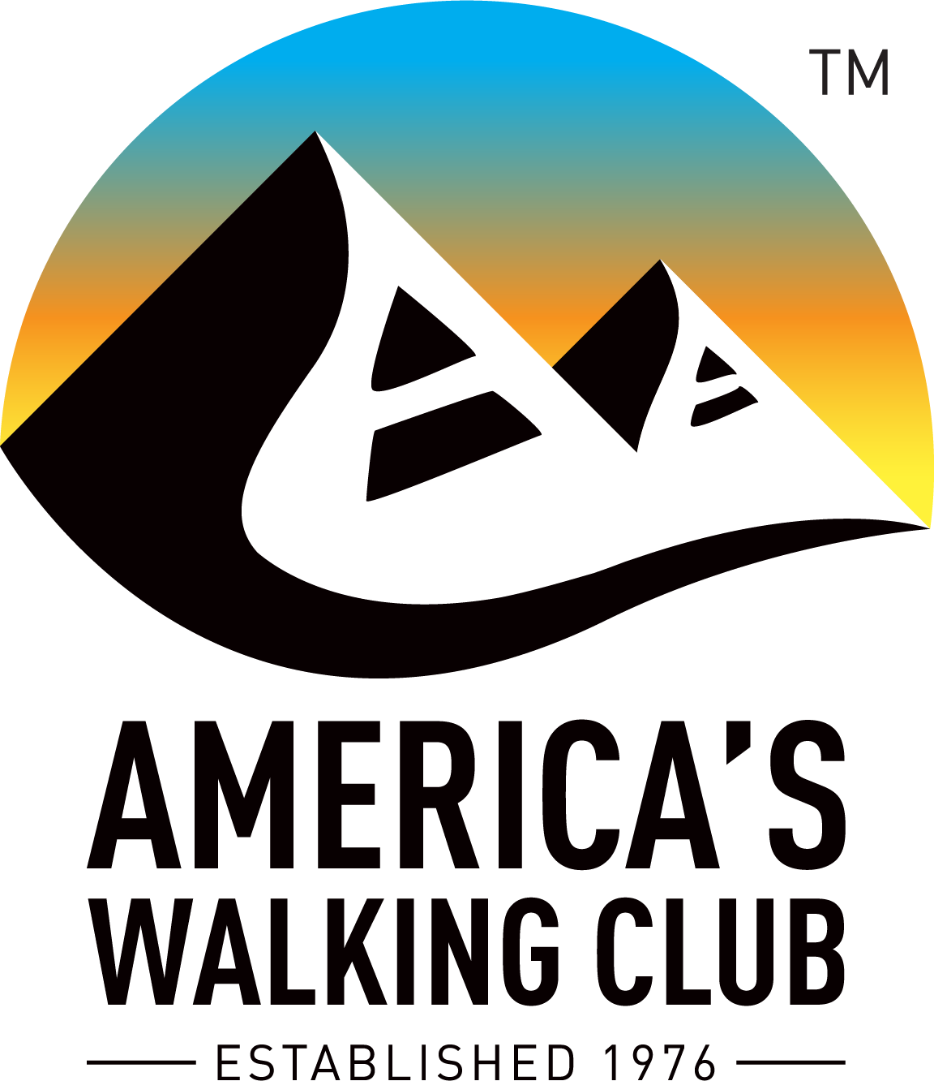

The Liberty Bell Wanderers
Welcomes You to
The Roebling Aqueduct Walk
An AVA Sanctioned Year Round Event
that crosses the state border between
Pennsylvania and New York
qualifying for the AVA “Border Crossings” Special Program
This walk is composed of a 5km loop with optional 5km extension (out and back extension) to make a 10 km walk. The initial 5km loop crosses the Delaware River via the Roebling Aqueduct from Pennsylvania into New York to do portion of the old canal tow path then back across the Aqueduct to Pennsylvania. Then the walk passes the Lackawaxen, PA US Post Office, the Lackawaxen Inn, the Zane Grey Museum, and crosses the Lackawaxen river. The 5km extension is an “out and back” walk on a quiet country road next to the Lackawaxen River in PA.
Both 5km loop and 5km extension are rated 1B. The walk start/end point is in the parking lot next to Roebling bridge entrance on the PA side. There is a permanent pit toilet building on the PA side of the bridge next to the start/end point parking lot. There are no restrooms on the NY side of the bridge. There are restrooms available in the Zane Grey Museum when it is open.
The Zane Grey Museum may be toured during or after your walk. The Museum season and hours are:
Memorial Day - Labor Day - Daily: 10:00 am- 5:00 pm; September 1 - September 30 - 10:00 am - 5:00 pm;
October - 10:00 am - 5:00 pm on weekends prior to middle of October. See the following link for details:
https://www.nps.gov/upde/planyourvisit/hours.htm
You are also strongly encouraged to visit/drive to the Minisink Battlefield Park that is located in NY on York Hill Rd (County 168) less than 0.5 miles uphill from bridge. The town park contains a number of short, easy, woodland walking paths that visit sites of historical interest for this Revolutionary War battlefield. Bathrooms and picnic tables are available in the park.
Walk Registration:
Registration takes place online using that AVA Online Start Box, on my.ava.org. Follow the instructions provided to create a user account and sign the AVA waiver (one time). Instructions for payment are also included. Download the directions and print as needed. The POC does not provide event directions or accept alternate payment methods.
Walk Completion and Walk Credit:
Once you have physically completed the walk, please login to your Online Start Box account click on the “My Start Box” tab, then the “Finish Table” tab, then click on “Go to Finish Table” button for the event you have completed. Use the displayed entry form to submit the date and distance of your walk as well as select applicable AVA Special Programs to generate stamped “virtual” insert cards that you may choose to print out.
Table of Contents:
Use the following table to guide what portion of this document you may wish to print out.

Section Contents | Pages
Introduction, Walk Registration/Completion, and Table of Contents | 1
Driving and Walk Directions | 2-3
Maps | 4
AVA Special Programs applicable to the Roebling Aqueduct Walk | 5

10km and 6km Walking Directions for the
Roebling Aqueduct Walk
Starting Point Location:
From Port Jervis, NY: Proceed North on scenic NY 97 with the Delaware River on your left for about 23 miles, watch for Roebling bridge. Turn Left to cross the one lane Roebling bridge. Immediately after crossing the bridge, Turn Left into a parking lot next to the Delaware River.
From Hancock, NY: Proceed South on NY 97 for 47 miles, watch Roebling bridge on your right. Turn Left to cross the one lane Roebling bridge. Immediately after crossing the bridge, Turn Left into a parking lot next to the Delaware River.
The street address of the intersection next to the start/end point parking lot is 155 Scenic Dr, Lackawaxen PA. (Lat: 41.481860, Lng: -74.986100 of parking lot)
Restrooms:
There is a permanent pit toilet building on the next to the starting point parking lot.
Insect repellent recommended especially for the tow path portion of the walk.

Emergency Numbers:
In case of Emergency: Dial 911
Event related assistance:
Mike Green: 845-781-6801

Walking Instructions:
Abbreviations used:
ns – No Sign. There is no street sign.
C&P – Cross and/or Pass. Usage – {C&P: 1st St and 2nd St.}
These walk directions and maps may only be used in conjunction with a signed American Volkssport Association athletic waiver. All other uses are prohibited.

Walk Directions:
- Starting with your back to Public Restrooms (pit toilets) walk towards the Delaware River to a view of the Roebling Bridge and the historical information signs at the end of the parking lot.
Take a moment to read the historical information sign that shows a cut-a-way view of the bridge illustrating the water level inside the bridge when it served as an aqueduct to carry canal boats across the Delaware River.
- At the end of the parking lot (facing the River) turn LEFT and follow the sidewalk as it turns LEFT passing more historical information signs and a large Wooden Frame, illustrating one of the key structural elements of the bridge.
This large wooden frame is a repetitive structural element of the bridge. Notice the 2 metal loops that are used to hang the frame from the bridge’s suspension cables.
The suspension cables follow a catenary shape between the support towers. The lengths of metal loops for each frame are chosen so as to compliment this shape and keep the frames horizontally aligned across the full length of the bridge.
- Keeping the Wooden Frame on your right follow the sidewalk as it loops back next to the bridge entrance road walking past the Wooden Frame again onto the wooden pedestrian walk (where the mules would pull canal boats across the bridge) on the south-side of the Roebling Bridge to the middle of the bridge.
!WARNING! Do NOT touch or slide your hand on the wooden “hand” rails as you walk cross the bridge to avoid getting wood splinters.
- The border between PA and NY is the middle of the Delaware River. Participants in the AVA “Border Crossings” special program may want to take a picture at this location.
- Continue on the wooden pedestrian walk into New York to concrete sidewalk.
On this end of the bridge, clear plastic panels have been installed permitting you to see the individual wires of the suspension cable. These are the original suspension wires installed in 1847 when the bridge was built. The wooden frames of the bridge were most recently restored in 1995 and at that time the suspension wires were found to be amazingly corrosion free.
If open, be sure to step inside the Toll House to see photographs from the canal boat period as well as a small room illustrating the living quarters aboard a canal boat.
- After the Toll house, follow the concrete sidewalk downhill as it turns left to the Roebling Bridge entrance road.
- Carefully CROSS the bridge entrance road and follow the sidewalk to concrete sidewalk next to parking lot (on the NY side of the Roebling Bridge) and proceed to the Tow Path Trail entrance at the end of the parking lot.
- Follow the Tow Path Trail as it goes down towards the river and loops back to the left and goes under the Roebling Bridge.
Enjoy the view of the bottom of the Bridge. Later in the walk there will be additional informational signs describing the history of the bridge. Although today it is single lane highway bridge, the most recent restoration preserved those structures that once made the bridge serve as an Aqueduct to carry Canal boats across the river. Notice the extended bridge piers on the right designed to break up ice flows and prevent damage to the bridge
- Continue (about 1 km) on the gravel Tow Path Trail next to the abandoned canal ditch, with the Delaware River on your right, to the large boulders marking the trail’s end next to a gravel parking area adjacent to Rte 97.
- TURN AROUND and retrace your steps back on the Tow Path Trail, with the Delaware River on left, under the Roebling Bridge looping up to the paved parking lot.
- Proceed through the paved parking lot and onto the concrete sidewalk turning RIGHT at the first fork to the wooden pedestrian walk on the north-side of the Roebling Bridge proceeding to the middle of the bridge.
WARNING! Do NOT touch or slide your hand on the wooden “hand” rails as you walk cross the bridge to avoid getting wood splinters.
- The border between NY and PA is the middle of the Delaware River. Participants in the AVA “Border Crossings” special program may want to take a picture at this location.
- Continue on the wooden pedestrian walk to the concrete sidewalk then on the left side of the road to the T intersection, Scenic Dr (ns).
- LEFT on Scenic Rd continue {C&P: Lackawaxen Post Office and Lackawaxen Inn} to the Railroad tracks.
- TURN AROUND at the Railroad tracks {C&P: Lackawaxen Inn and the Post Office} and go back to the Roebling Bridge entrance.
- Pass the Roebling Bridge entrance and continue on this paved road as it turns right then left keeping the Delaware River on your right {C&P: Lackawaxen and Union Cemetery} to the entrance road of the Zane Grey Museum parking lot.
Zane Grey is buried in the Lackawaxen and Union Cemetery Also notice the grave of an unknown Revolutionary War soldier next to the road who died in the “Minisink Massacre”. This battlefield is located directly across the Delaware river in New York near the top the hill in a town park that provides self-guided trails through the battlefield.
- Continue past the parking lot entrance walking on the left side of the road and following the road as it curves to the left {C&P: Under the railroad bridge and the Two River Junction shops} to the stop sign at Rte 590 (aka, Hamlin Highway).
WALK on the RIGHT, before you pass under the railroad bridge to see and be seen by traffic coming around the curve before this bridge.
- CROSS and immediately turn RIGHT onto Rte 590 crossing the Zane Grey Bridge over the Lackawaxen River to the end of the bridge.
- Turn RIGHT to cross Rte 590 and then immediately RIGHT walking on the other side of the bridge back to Scenic Dr / LCPL Jacob Beisel Rd.
- 5 KM WALKERS ONLY: LEFT onto Scenic Drive then Skip to Instruction 25).
- 10 KM WALKERS ONLY: RIGHT crossing Rte 590 onto LCPL Jacob Beisel Rd (that is also known as Beisel Beck Rd)
About ½ km from Rte 590 intersection, where the Beisel road starts to get closer to the Lackawaxen River, look to the right across the river to see the remains of the stone work foundation for an Aqueduct that carried canal boats over the Lackawaxen River.
- Continue for 2.5 km walking with the river on your right {C&P: railroad tracks, small bridge over Lords Creek (ns), Johanson Lane} to the end Beisel Beck Rd indicated by the sign, “Do not enter, Private Rd, No Trespassing”.
- TURN AROUND and RETRACE your steps on Beisel Beck Rd back to Rte 590 walking with the river on your left to Rte 590.
- Cross Rte 590 onto Scenic Drive.
- 5 KM and 10 KM WALKERS: Continue on Scenic Dr retracing your steps {C&P: The Two River Junction shops and under the railroad bridge} to the Zane Grey Museum.
- Continue past Zane Grey Museum on Scenic Dr to the next intersection with entrance to the Roebling Bridge.
- Cross the bridge entrance road then Turn LEFT to the parking lot entrance and the walk start/finish.
We hope you enjoyed your walk. If you have not already done so, please login to my.ava.org then click on the “My Start Box” tab, then the “Finish Table” tab to “complete” your walk.

Roebling Aqueduct 5 & 10 km Walk Map

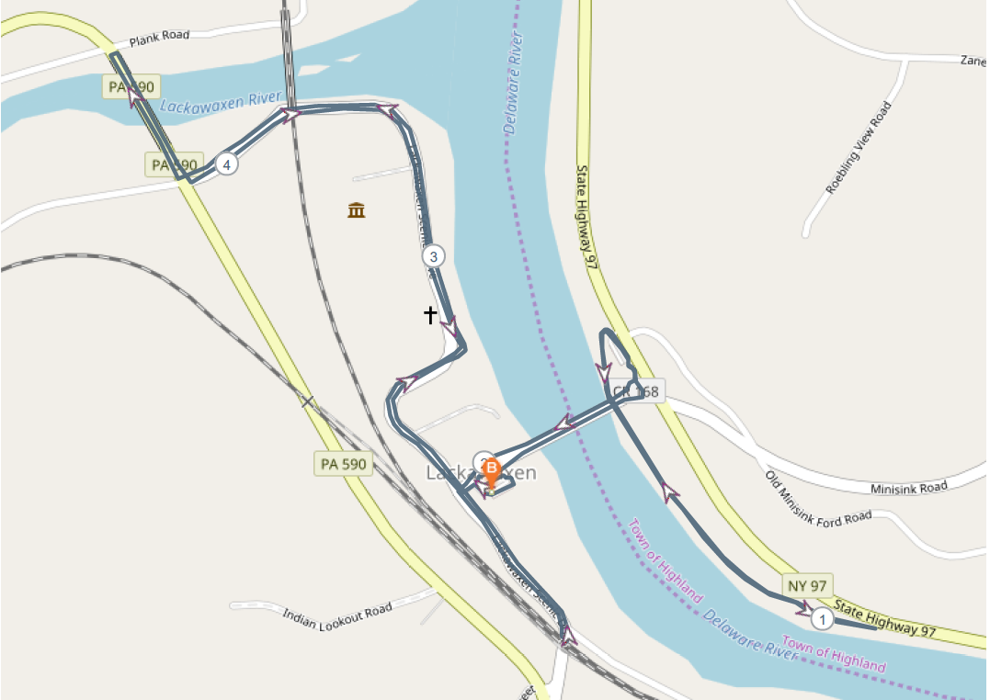

Walk
Start Point
10 Km Walkers Only
New York
Pennsylvania
Zane Grey Museum

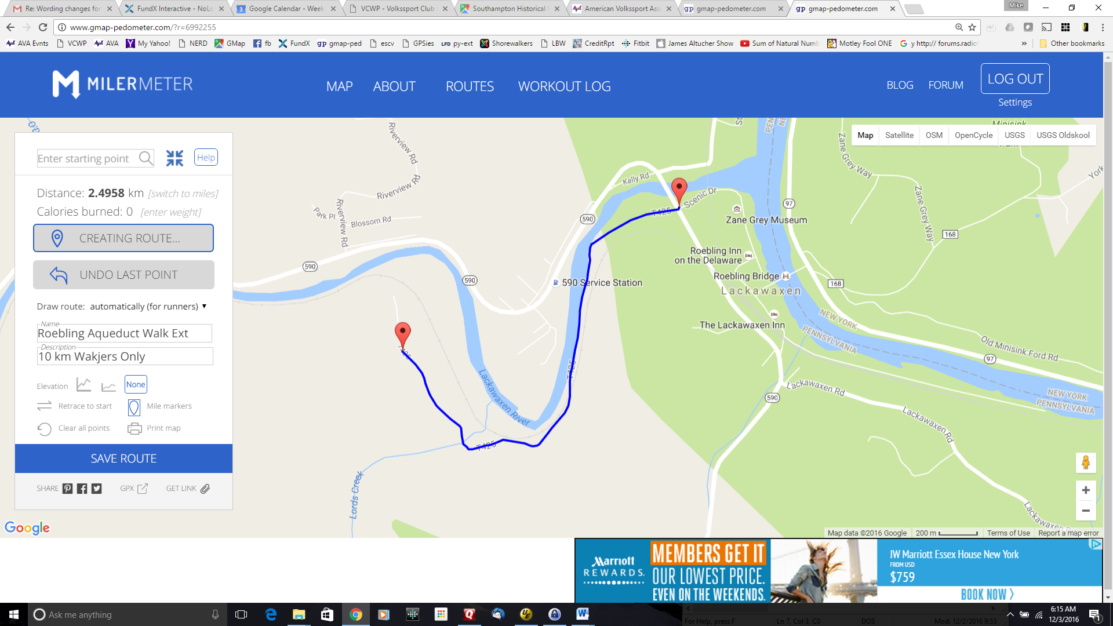
Turn
Around
Point
10km split
from 5km
Out and Back for 10 KM Walkers Only
Walk
Start Point

